Design Meeting with Supervisor
Week 6 – 5th /06/2018

Clarity Leaflet Initial Design Feedback:

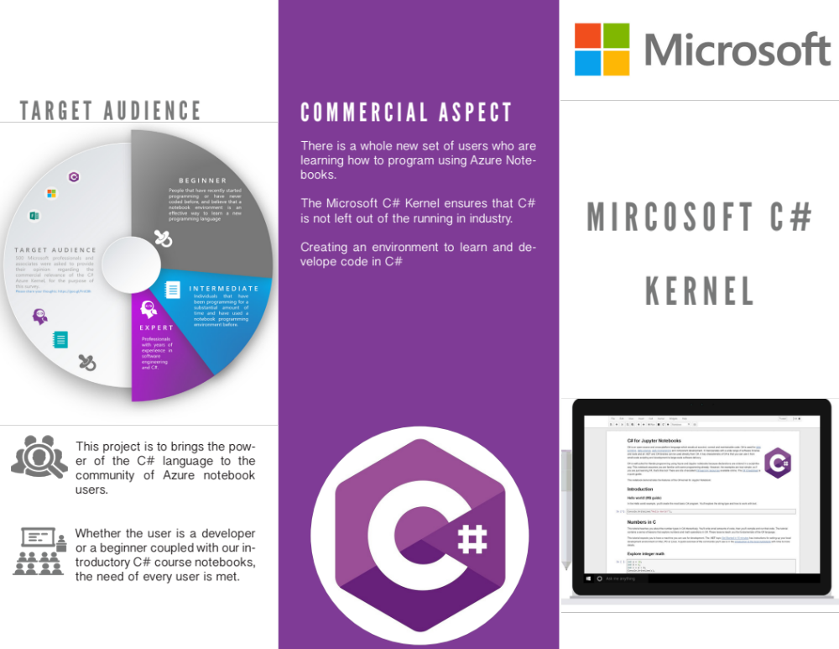

Supervisor Sabhi Feedback:

Initial page:
- Needs to be more attractive
- Add better resolution tablet screenshot
- Come up with a tagline

Commercial Aspect:
- Add image about C# impact in the world
- Emphasize it’s the 1st and only C# kernel in the market

Target Audience:
- Remove text from the pie char (too small to read)
- Reorganise this page

Concept:
- Reduce text and use catch phrases
Solution
- Proof read
- Realign icons
- Highlight key text

Implementation
- Proof read
- Realign icons
- Highlight key text

